R Programming 30-Day Learning Plan - Complete Summary Guide
Based on your learning module, here's a comprehensive overview of what you need to learn in 30+ days, with summarized code for each section.

📅 PHASE 1: R BASICS & DATA STRUCTURES (Days 1-7)

Day 1: R Basics & Setup

What to learn:
- Installing R/RStudio, console layout
- Basic arithmetic operations
- Assignment operators (<-)
- Basic data types (numeric, character, logical)

Summary Code:
r
# Basic Calculations
2 + 2 # Addition
10 - 5 # Subtraction
3 * 4 # Multiplication
20 / 4 # Division
2 ^ 3 # Exponentiation
10 %% 3 # Modulo

# Variables & Assignment
gdp_growth <- 3.5
inflation_rate <- 2.1
total_indicator <- gdp_growth + inflation_rate
print(total_indicator)
[1] 5.6

# Data Types
country_name <- "Malaysia" # Character
population_millions <- 33.5 # Numeric
is_developed <- FALSE # Logical
# Check the data type of a variable using class()
>class(country_name) # Returns "character"
[1] "character"
> class(population_millions) # Returns "numeric"
[1] "numeric"
> class(is_developed) # Returns "logical"
[1] "logical"

Day 2: Data Structures - Vectors & Matrices
What to learn:
- Creating atomic vectors
- Vector indexing and filtering
- Vector recycling
- Creating and indexing matrices

Summary Code:
r
#Creating Vector
# Numeric vector (e.g., quarterly GDP growth rates)
gdp_growth <- c(2.1, 2.5, 1.8, 3.0)

# Character vector (e.g., country names)
countries <- c("Malaysia", "Indonesia", "Thailand")

# Logical vector
is_growing <- c(TRUE, TRUE, FALSE, TRUE)

#Vector indexing
# R is 1-indexed (the first element is at position 1, not 0)
gdp_growth[1] # Returns the first element: 2.1
[1] 2.1

gdp_growth[c(1, 3)] # Returns the 1st and 3rd elements: 2.1, 1.8
[1] 2.1 1.8

# Filtering vector elements using conditions
gdp_growth[gdp_growth > 2.0] # Returns values greater than 2.0
[1] 2.1 2.5 3.0

#Vectro recycling in math
prices <- c(100, 200, 300)
tax_rate <- 0.05

# Multiplying every element by a single number
total_tax <- prices * tax_rate
print(total_tax) # Returns 5, 10, 15
[1] 5 10 15

# Create a 3x2 matrix (3 rows, 2 columns) filled with numbers 1 to 6
# byrow = TRUE fills the matrix row by row instead of column by column
economic_matrix <- matrix(c(1, 2, 3, 4, 5, 6), nrow = 3, ncol = 2, byrow = TRUE)
print(economic_matrix)
[,1] [,2]
[1,] 1 2
[2,] 3 4
[3,] 5 6

# bycol = TRUE fills the matrix column by column instead of row by row
economic_matrix <- matrix(c(1, 2, 3, 4, 5, 6), nrow = 3, ncol = 2, byrow = FALSE)
print(economic_matrix)
[,1] [,2]
[1,] 1 4
[2,] 2 5
[3,] 3 6

# Extracting elements from a matrix: matrix_name[row, column]
economic_matrix[1, 2] # Extracts element at Row 1, Column 2
economic_matrix[2, ] # Extracts the entire Row 2
economic_matrix[, 1] # Extracts the entire Column 1

Day 3: Data Structures - Lists & Data Frames
What to learn:
- Building lists with mixed data types
- Creating and mastering Data Frames
- Inspecting data frames

Summary Code:
r
# Lists can store completely different objects together
# CREATING AND ACCESSING LISTS
country_info <- list(
country = "Malaysia",
gdp_growth = c(2.1, 2.5, 3.0),
is_developed = FALSE
)

print(country_info)

$country
[1] "Malaysia"

$gdp_growth
[1] 2.1 2.5 3.0

$is_developed
[1] FALSE

# Accessing list elements using double square brackets [[]] or $
country_info$country # Returns "Malaysia"
[1] "Malaysia"

country_info[[2]] # Returns the gdp_growth vector
[1] 2.1 2.5 3.0

# Building a structured economic dataset manually
macro_data <- data.frame(
Country = c("Malaysia", "Indonesia", "Thailand", "Singapore"),
Year = c(2023, 2023, 2023, 2023),
GDP_Growth = c(3.7, 5.0, 1.9, 1.1),
Inflation = c(2.5, 3.7, 1.2, 0.5)
)

print(macro_data)

Country Year GDP_Growth Inflation
1 Malaysia 2023 3.7 2.5
2 Indonesia 2023 5.0 3.7
3 Thailand 2023 1.9 1.2
4 Singapore 2023 1.1 0.5

# INSPECTING DATA FRAMES
head(macro_data) # View the first few rows
Country Year GDP_Growth Inflation
1 Malaysia 2023 3.7 2.5
2 Indonesia 2023 5.0 3.7
3 Thailand 2023 1.9 1.2
4 Singapore 2023 1.1 0.5

str(macro_data) # Check structure and data types of each column
'data.frame': 4 obs. of 4 variables:
$ Country : chr "Malaysia" "Indonesia" "Thailand" "Singapore"
$ Year : num 2023 2023 2023 2023
$ GDP_Growth: num 3.7 5 1.9 1.1
$ Inflation : num 2.5 3.7 1.2 0.5

summary(macro_data) # Get quick descriptive statistics for each column
Country Year GDP_Growth Inflation
Length :4 Min. :2023 Min. :1.100 Min. :0.500
N.unique :4 1st Qu.:2023 1st Qu.:1.700 1st Qu.:1.025
N.blank :0 Median :2023 Median :2.800 Median :1.850
Min.nchar:8 Mean :2023 Mean :2.925 Mean :1.975
Max.nchar:9 3rd Qu.:2023 3rd Qu.:4.025 3rd Qu.:2.800
Max. :2023 Max. :5.000 Max. :3.700

# ACCESSING COLUMNS IN A DATA FRAME
# Use the $ operator to extract a specific column as a vector
macro_data$GDP_Growth # Returns just the numeric growth column
[1] 3.7 5.0 1.9 1.1

# Calculate the mean GDP growth across these countries
mean(macro_data$GDP_Growth)
[1] 2.925

macro_data$Inflation
[1] 2.5 3.7 1.2 0.5

mean(macro_data$Inflation)
[1] 1.975

Day 4: Subsetting & Indexing
What to learn:
- Extracting data using [], [[]], and $ operators
- Filtering with conditions
- Multiple condition filtering

Summary Code:
r
# 0. SETUP: Create a sample economic dataset

macro_data <- data.frame(
Country = c("Malaysia", "Indonesia", "Thailand", "Singapore", "Vietnam"),
Year = c(2023, 2023, 2023, 2023, 2023),
GDP_Growth = c(3.7, 5.0, 1.9, 1.1, 5.05),
Inflation = c(2.5, 3.7, 1.2, 0.5, 3.2)
)
print(macro_data)
Country Year GDP_Growth Inflation
1 Malaysia 2023 3.70 2.5
2 Indonesia 2023 5.00 3.7
3 Thailand 2023 1.90 1.2
4 Singapore 2023 1.10 0.5
5 Vietnam 2023 5.05 3.2

# 1. INDEXING BY POSITION [row, column]
macro_data[1, 3] # Row 1, Column 3 (Malaysia's GDP Growth: 3.7)
[1] 3.7

macro_data[1:3, ] # Rows 1 through 3, all columns
Country Year GDP_Growth Inflation
1 Malaysia 2023 3.7 2.5
2 Indonesia 2023 5.0 3.7
3 Thailand 2023 1.9 1.2

macro_data[, c(1, 3)] # All rows, but only Column 1 and Column 3
Country GDP_Growth
1 Malaysia 3.70
2 Indonesia 5.00
3 Thailand 1.90
4 Singapore 1.10
5 Vietnam 5.05

# 2. INDEXING BY COLUMN NAME ($)
macro_data$Country # Extracts the 'Country' column as a vector
[1] "Malaysia" "Indonesia" "Thailand" "Singapore" "Vietnam"

macro_data[, "Inflation"] # Alternative way to extract by column name
[1] 2.5 3.7 1.2 0.5 3.2

# 3. CONDITIONAL FILTERING (ROWS)
# Method A: Using logical indexing inside brackets
high_growth <- macro_data[macro_data$GDP_Growth > 3.0, ]
print(high_growth) # Shows countries with GDP growth greater than 3.0
Country Year GDP_Growth Inflation
1 Malaysia 2023 3.70 2.5
2 Indonesia 2023 5.00 3.7
5 Vietnam 2023 5.05 3.2

# Method B: Using the subset() function (often cleaner for econometrics)
indonesia_data <- subset(macro_data, Country == "Indonesia")
print(indonesia_data)
Country Year GDP_Growth Inflation
2 Indonesia 2023 5 3.7

malaysia_data <- subset(macro_data, Country == "Malaysia")
print(malaysia_data)
Country Year GDP_Growth Inflation
1 Malaysia 2023 3.7 2.5

#Filtering with multiple conditions (AND operator '&')
filtered_data <- subset(macro_data, GDP_Growth > 2.0 & Inflation < 3.0)
print(filtered_data)
Country Year GDP_Growth Inflation
1 Malaysia 2023 3.7 2.5

Day 5: Control Flow
What to learn:
- if-else statements
- for loops
- while loops
- Vectorized ifelse

Summary Code:
r
# If-Else Statements
gdp_growth <- 3.5
if (gdp_growth > 4.0) {
print("High Economic Growth")
} else if (gdp_growth >= 2.0 & gdp_growth <= 4.0) {
print("Moderate Economic Growth")
} else {
print("Low Growth / Recession Risk")
}
[1] "Moderate Economic Growth"

# Vectorized ifelse
inflation_rates <- c(1.2, 4.5, 2.1, 6.0)
inflation_status <- ifelse(inflation_rates > 3.0, "High Inflation", "Stable")

# For Loops
years <- c(2021, 2022, 2023)
for (y in years) {
print(paste("Analyzing macroeconomic data for year:", y))
}
[1] "Analyzing macroeconomic data for year: 2021"
[1] "Analyzing macroeconomic data for year: 2022"
[1] "Analyzing macroeconomic data for year: 2023"

# While Loops
capital <- 100
target_capital <- 150
years_passed <- 0
while (capital < target_capital) {
capital <- capital * 1.05
years_passed <- years_passed + 1
}
print(paste("Target reached in", years_passed, "years."))
[1] "Target reached in 9 years."

Day 6: Custom Functions & Scope
hat to learn:
- Defining functions
- Function arguments and return values
- Variable scope (local vs global)

Summary Code:
r
# Basic Function
calculate_growth <- function(initial_value, final_value) {
growth_rate <- ((final_value - initial_value) / initial_value) * 100
return(growth_rate)
}
calculate_growth(1000, 1050) # Returns 5
[1] 5

# Functions with Default Arguments
calculate_tax <- function(income, tax_rate = 0.15) {
tax_amount <- income * tax_rate
return(tax_amount)
}
calculate_tax(50000) # Uses default 0.15
[1] 7500

calculate_tax(50000, 0.20) # Overrides default
[1] 10000

# Scope
multiplier <- 2 # Global variable
my_calculation <- function(x) {
multiplier <- 10 # Local variable
result <- x * multiplier
return(result)
}
my_calculation(5) # Returns 50
[1] 50

print(multiplier) # Returns 2 (global unchanged)
[1] 2

Day 7: Basic Input/Output
What to learn:
- Importing CSV, TXT, Excel files
- Exporting data frames
- Working directories

Summary Code:
r
# Working Directory
getwd()
# setwd("C:/Your/Path/Here")

# Importing CSV
# economic_data <- read.csv("macro_data.csv", header = TRUE)
# head(economic_data)

# Exporting CSV
cleaned_data <- data.frame(
Country = c("Malaysia", "Indonesia"),
Growth = c(4.0, 5.1)
)
write.csv(cleaned_data, file = "cleaned_macro_data.csv", row.names = FALSE)

# Reading Excel
# install.packages("readxl")
library(readxl)
# excel_data <- read_excel("economic_indicators.xlsx", sheet = "Sheet1")

📅 PHASE 2: DATA WRANGLING WITH TIDYVERSE (Days 8-14)
Day 8: Introduction to Tidyverse
What to learn:
- Tidyverse ecosystem overview
- Pipe operator (%>% or |>)
- Tibbles vs data frames

Summary Code:
r
# Install and Load
# install.packages("tidyverse")
library(tidyverse)

# Tibbles
base_df <- data.frame(
country = c("Malaysia", "Indonesia", "Thailand"),
gdp_growth = c(3.7, 5.0, 1.9),
year = c(2023, 2023, 2023)
)
macro_tbl <- as_tibble(base_df)

# Pipe Operator
inflation <- c(2.5, 3.1, 1.8, 4.2)
result_piped <- inflation |>
mean() |>
round(digits = 1)

# Piping with Data Frames
macro_tbl |> summary()

country gdp_growth year
Length :3 Min. :1.900 Min. :2023
N.unique :3 1st Qu.:2.800 1st Qu.:2023
N.blank :0 Median :3.700 Median :2023
Min.nchar:8 Mean :3.533 Mean :2023
Max.nchar:9 3rd Qu.:4.350 3rd Qu.:2023
Max. :5.000 Max. :2023

Day 9: Data Wrangling - dplyr Part 1
What to learn:
- select() - subset columns
- filter() - subset rows
- arrange() - sort rows

Summary Code:
r
library(tidyverse)

macro_df <- data.frame(
Country = c("Malaysia", "Indonesia", "Thailand", "Singapore", "Vietnam"),
Year = c(2023, 2023, 2023, 2023, 2023),
GDP_Growth = c(3.7, 5.0, 1.9, 1.1, 5.05),
Inflation = c(2.5, 3.7, 1.2, 0.5, 3.2)
)

# select() - Column Selection
macro_df |> select(Country, GDP_Growth)
Country GDP_Growth
1 Malaysia 3.70
2 Indonesia 5.00
3 Thailand 1.90
4 Singapore 1.10
5 Vietnam 5.05

macro_df |> select(-Year) # Drop column
Country GDP_Growth Inflation
1 Malaysia 3.70 2.5
2 Indonesia 5.00 3.7
3 Thailand 1.90 1.2
4 Singapore 1.10 0.5
5 Vietnam 5.05 3.2

# filter() - Row Filtering
macro_df |> filter(GDP_Growth > 3.0)
Country Year GDP_Growth Inflation
1 Malaysia 2023 3.70 2.5
2 Indonesia 2023 5.00 3.7
3 Vietnam 2023 5.05 3.2

macro_df |> filter(Country == "Malaysia")
Country Year GDP_Growth Inflation
1 Malaysia 2023 3.7 2.5

macro_df |> filter(GDP_Growth > 3.0 & Inflation < 3.0)
Country Year GDP_Growth Inflation
1 Malaysia 2023 3.7 2.5

# arrange() - Sorting
macro_df |> arrange(GDP_Growth) # Ascending
Country Year GDP_Growth Inflation
1 Singapore 2023 1.10 0.5
2 Thailand 2023 1.90 1.2
3 Malaysia 2023 3.70 2.5
4 Indonesia 2023 5.00 3.7
5 Vietnam 2023 5.05 3.2

macro_df |> arrange(desc(GDP_Growth)) # Descending
Country Year GDP_Growth Inflation
1 Vietnam 2023 5.05 3.2
2 Indonesia 2023 5.00 3.7
3 Malaysia 2023 3.70 2.5
4 Thailand 2023 1.90 1.2
5 Singapore 2023 1.10 0.5

Day 10: Data Wrangling - dplyr Part 2
What to learn:
- mutate() - create new columns
- case_when() - conditional mutations

Summary Code:
r
library(tidyverse)

macro_df <- data.frame(
Country = c("Malaysia", "Indonesia", "Thailand", "Singapore"),
GDP = c(400, 1300, 500, 450),
Population = c(33.5, 275.5, 71.7, 5.6)
)

# mutate() - Create New Columns
macro_mutated <- macro_df |>
mutate(GDP_per_capita = GDP / Population)

macro_transformed <- macro_df |>
mutate(Log_GDP = log(GDP)) # Natural log transformation

# case_when() - Conditional Mutations
macro_categorized <- macro_mutated |>
mutate(Economic_Tier = case_when(
GDP_per_capita > 50 ~ "High Income",
GDP_per_capita > 10 ~ "Middle Income",
TRUE ~ "Developing" # Catch-all else
))

Day 11: Data Aggregation
What to learn:
- group_by() - grouping data
- summarize() - summarizing grouped data

Summary Code:
r
library(tidyverse)

panel_df <- data.frame(
Region = c("Asia", "Asia", "Asia", "Europe", "Europe", "Europe"),
Country = c("Malaysia", "Indonesia", "Thailand", "Germany", "France", "Italy"),
Year = c(2023, 2023, 2023, 2023, 2023, 2023),
Inflation = c(2.5, 3.7, 1.2, 5.2, 4.8, 5.9)
)
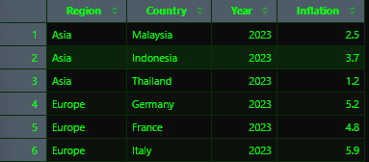

# Group and Summarize
region_summary <- panel_df |>
group_by(Region) |>
summarize(
Avg_Inflation = mean(Inflation),
Max_Inflation = max(Inflation),
Country_Count = n()
) |>
ungroup()



Day 12: Combining Datasets
What to learn:
- left_join(), inner_join(), full_join()
- Binding functions

Summary Code:
r
library(tidyverse)

gdp_data <- data.frame(
Country = c("Malaysia", "Indonesia", "Thailand", "Singapore"),
GDP_Growth = c(3.7, 5.0, 1.9, 1.1)
)

pop_data <- data.frame(
Country = c("Malaysia", "Indonesia", "Thailand", "Vietnam"),
Population_Mil = c(33.5, 275.5, 71.7, 98.2)
)

# left_join - Keep all rows from left table
left_merged <- gdp_data |> left_join(pop_data, by = "Country")



# inner_join - Keep only rows in both tables
inner_merged <- gdp_data |> inner_join(pop_data, by = "Country")


# full_join - Keep all rows from both tables
full_merged <- gdp_data |> full_join(pop_data, by = "Country")
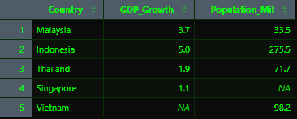

Day 13: Data Reshaping with tidyr
What to learn:
- pivot_longer() - wide to long
- pivot_wider() - long to wide

Summary Code:
r
library(tidyverse)

# Wide Format
wide_macro <- data.frame(
Country = c("Malaysia", "Indonesia"),
Y2021 = c(3.1, 3.7),
Y2022 = c(8.7, 5.3),
Y2023 = c(3.7, 5.0)
)



# Wide to Long
long_macro <- wide_macro |>
pivot_longer(
cols = starts_with("Y"),
names_to = "Year",
values_to = "GDP_Growth"
)

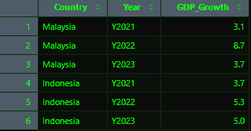

# Long to Wide
back_to_wide <- long_macro |>
pivot_wider(
names_from = Year,
values_from = GDP_Growth
)


Day 14: Mini-Project 1
What to learn:
- End-to-end data cleaning pipeline
- Applying all tidyverse tools

Summary Code:
r
library(tidyverse)

raw_data <- data.frame(
Country = c("Malaysia", "Indonesia", "Thailand", "Singapore", "Vietnam"),
Region = c("SE Asia", "SE Asia", "SE Asia", "SE Asia", "SE Asia"),
Y2021 = c(3.1, 3.7, 1.5, 7.6, 2.6),
Y2022 = c(8.7, 5.3, 2.6, 3.8, 8.0),
Inflation_2022 = c(2.5, 4.2, 6.1, 6.1, 3.2)
)

# Complete Wrangling Pipeline
processed_data <- raw_data |>
pivot_longer(cols = starts_with("Y"),
names_to = "Year",
values_to = "GDP_Growth") |>
mutate(Year = str_remove(Year, "Y"),
Year = as.numeric(Year)) |>
filter(GDP_Growth > 2.0) |>
mutate(Performance_Tier = case_when(
GDP_Growth > 5.0 ~ "High Growth",
TRUE ~ "Moderate Growth"
)) |>
group_by(Year) |>
mutate(Avg_Annual_Growth = mean(GDP_Growth)) |>
ungroup()

# Export cleaned data
write.csv(processed_data, file = "cleaned_macro_pipeline_output.csv", row.names = FALSE)

📅 PHASE 3: DATA VISUALIZATION (Days 15-21)
Day 15: Introduction to ggplot2
What to learn:
- Grammar of Graphics
- Building the canvas
- Adding geometric layers
Summary Code:
r
library(tidyverse)

economic_trend <- data.frame(
Year = c(2019, 2020, 2021, 2022, 2023),
GDP_Growth = c(4.3, -5.5, 3.1, 8.7, 3.7)
)

# Canvas
ggplot(data = economic_trend, mapping = aes(x = Year, y = GDP_Growth))

# Points
ggplot(economic_trend, aes(x = Year, y = GDP_Growth)) + geom_point()

# Lines
ggplot(economic_trend, aes(x = Year, y = GDP_Growth)) + geom_line()

# Combined
ggplot(economic_trend, aes(x = Year, y = GDP_Growth)) +
geom_line(color = "blue", linewidth = 1) +
geom_point(color = "darkblue", size = 3)

Day 16: Basic Plots
What to learn:
- Scatter plots (geom_point)
- Line charts (geom_line)
- Showing relationships

Summary Code:
r
library(tidyverse)

macro_panel <- data.frame(
Country = rep(c("Malaysia", "Indonesia", "Thailand"), each = 4),
Year = rep(2020:2023, times = 3),
GDP_Growth = c(-5.5, 3.1, 8.7, 3.7, -2.1, 3.7, 5.3, 5.0, -6.1, 1.5, 2.6, 1.9)
)

# Single Country Line
macro_panel |>
filter(Country == "Malaysia") |>
ggplot(aes(x = Year, y = GDP_Growth)) +
geom_line(color = "blue", linewidth = 1.2) +
geom_point(color = "darkblue", size = 2)

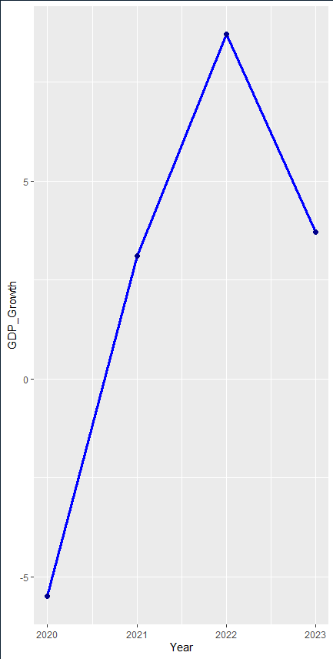

# Multi-Country Lines
ggplot(macro_panel, aes(x = Year, y = GDP_Growth, color = Country)) +
geom_line(linewidth = 1) +
geom_point(size = 2)

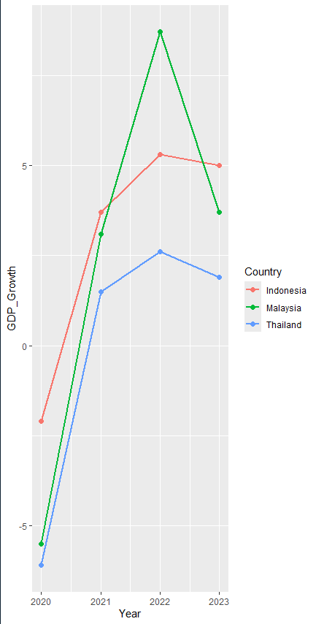
# Customized
ggplot(macro_panel, aes(x = Year, y = GDP_Growth, color = Country, linetype = Country)) +
geom_line(linewidth = 1) +
geom_point(size = 2) +
labs(title = "GDP Growth Trajectories by Country (2020-2023)",
x = "Year", y = "Annual GDP Growth (%)")

Day 17: Distribution Plots
What to learn:
- Histograms (geom_histogram)
- Box plots (geom_boxplot)
- Bar charts

Summary Code:
r
library(tidyverse)
data(mtcars)

# Scatter Plot
ggplot(mtcars, aes(x = wt, y = mpg)) +
geom_point(color = "darkred", size = 3) +
labs(title = "Fuel Economy vs. Weight", x = "Weight (1000 lbs)", y = "MPG")

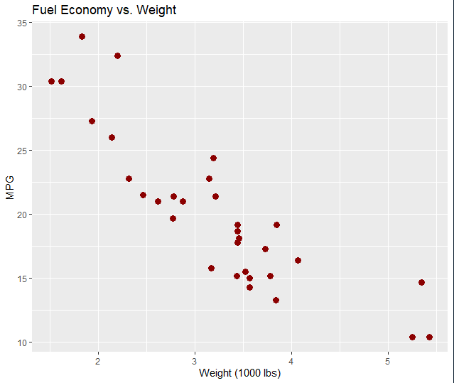
# Scatter with OLS Line
ggplot(mtcars, aes(x = wt, y = mpg)) +
geom_point(aes(color = as.factor(cyl))) +
geom_smooth(method = "lm", se = TRUE, color = "black", linetype = "dashed")
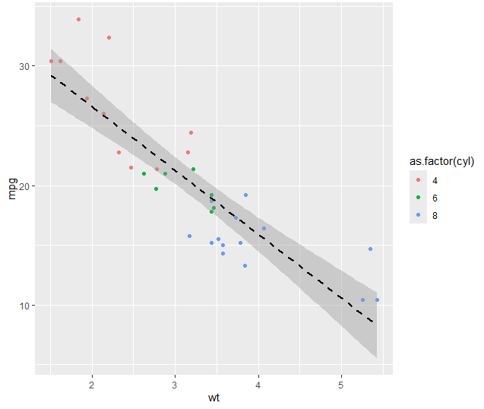

# Histogram
ggplot(mtcars, aes(x = mpg)) +
geom_histogram(bins = 8, fill = "steelblue", color = "white") +
labs(title = "Histogram of MPG", x = "MPG", y = "Frequency")

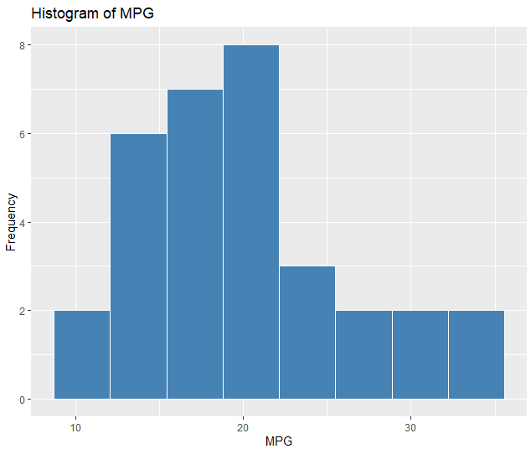

# Box Plot
ggplot(mtcars, aes(x = as.factor(cyl), y = mpg, fill = as.factor(cyl))) +
geom_boxplot() +
labs(title = "MPG by Cylinder Count", x = "Cylinders", y = "MPG")

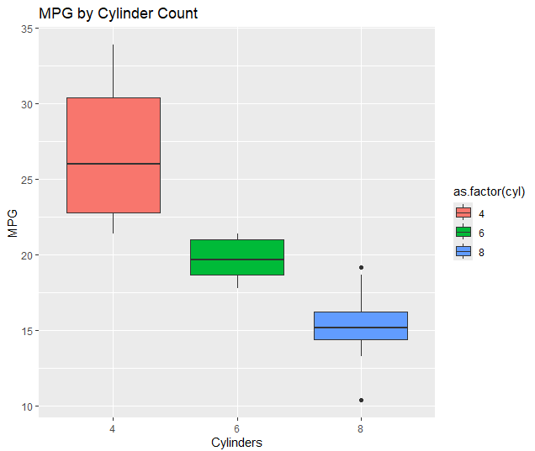

Day 18: Customizing Visualizations
What to learn:
- Titles, labels, axis modifications
- Custom themes
- Color palettes (scale_color_*)

Summary Code:
r
library(tidyverse)
data(mtcars)
mtcars$cyl_factor <- as.factor(mtcars$cyl)

# Base Plot with Labels
base_plot <- ggplot(mtcars, aes(x = wt, y = mpg, color = cyl_factor)) +
geom_point(size = 3) +
labs(
title = "Vehicle Fuel Economy vs. Weight",
subtitle = "Analysis of 1974 Motor Trend US Magazine",
x = "Vehicle Weight (1,000 lbs)",
y = "Miles Per Gallon (MPG)",
color = "Cylinders",
caption = "Source: Built-in R dataset (mtcars)"
)

# Themes
base_plot + theme_bw() # Black and white theme
base_plot + theme_minimal() # Minimal theme

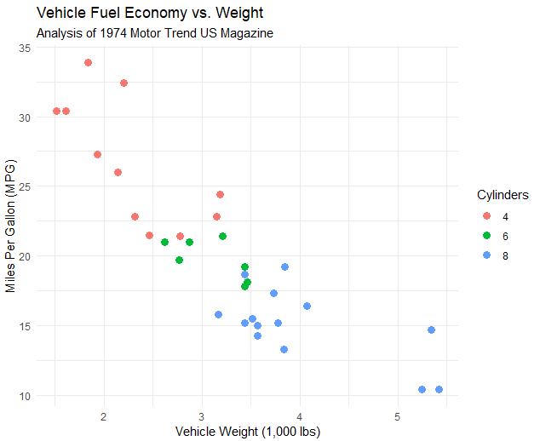

# Full Customization
ggplot(mtcars, aes(x = wt, y = mpg, color = cyl_factor)) +
geom_point(size = 3, alpha = 0.8) +
geom_smooth(method = "lm", se = FALSE, linetype = "dashed") +
labs(title = "Econometric Relationship: Weight vs. MPG",
subtitle = "Controlled by Cylinder Sub-groups",
x = "Weight (1,000 lbs)", y = "Miles Per Gallon", color = "Cylinders") +
scale_color_manual(values = c("#E41A1C", "#377EB8", "#4DAF4A")) +
theme_minimal(base_size = 12) +
theme(
plot.title = element_text(face = "bold", size = 14, color = "darkslategrey"),
legend.position = "bottom",
panel.grid.minor = element_blank()
)

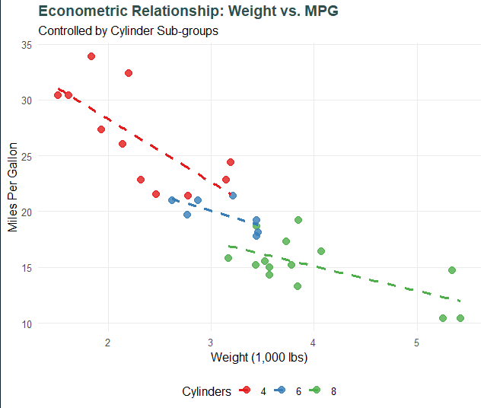

Day 19: Multi-Panel Plots & Faceting
What to learn:
- facet_wrap() - 1D categories
- facet_grid() - 2D matrices

Summary Code:
r
library(tidyverse)

set.seed(123)
panel_data <- data.frame(
Country = rep(c("Malaysia", "Indonesia", "Thailand", "Vietnam"), each = 5),
Year = rep(2019:2023, times = 4),
Sector = rep(c("Manufacturing", "Services"), times = 10),
GDP_Growth = rnorm(20, mean = 4.0, sd = 1.5)
)

# facet_wrap - One dimension
ggplot(panel_data, aes(x = Year, y = GDP_Growth, color = Country)) +
geom_line(linewidth = 1) +
geom_point(size = 2) +
facet_wrap(~ Country, ncol = 2) +
labs(title = "GDP Growth by Country", x = "Year", y = "Growth (%)") +
theme_bw() +
theme(legend.position = "none")

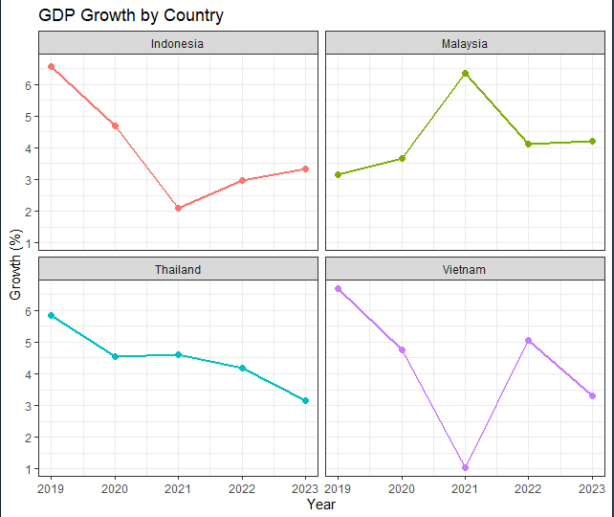

# facet_grid - Two dimensions (Country rows, Sector columns)
ggplot(panel_data, aes(x = Year, y = GDP_Growth)) +
geom_col(fill = "steelblue") +
facet_grid(Country ~ Sector) +
labs(title = "GDP Growth Matrix: Country vs. Sector",
x = "Year", y = "Growth (%)") +
theme_bw()

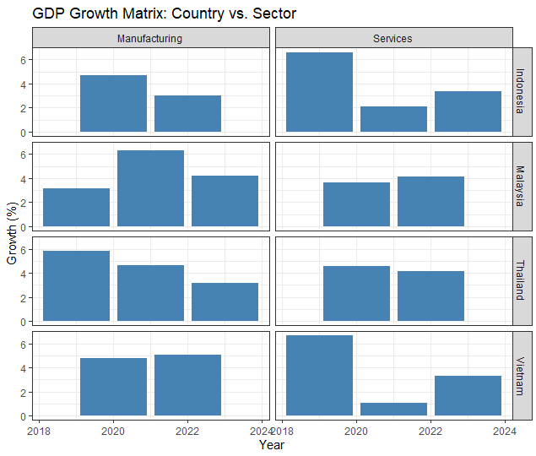

# Free Scales
ggplot(panel_data, aes(x = Year, y = GDP_Growth, color = Sector)) +
geom_line(linewidth = 1) +
facet_wrap(~ Country, scales = "free_y") +
labs(title = "Faceted Plot with Free Y-Scales", x = "Year", y = "Growth (%)") +
theme_minimal()
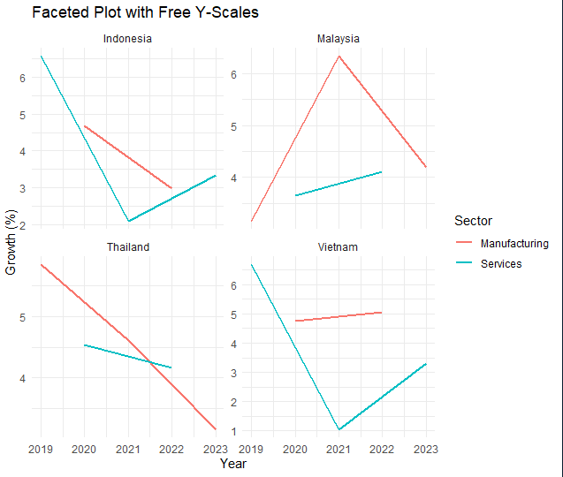

Day 20: Exploratory Data Analysis (EDA)
What to learn:
- Summary statistics
- Correlations
- Handling missing values

Summary Code:
r
library(tidyverse)

# Setup with missing values
eda_df <- mtcars
eda_df$mpg[c(3, 12)] <- NA
eda_df$hp[c(5, 20)] <- NA

# Structure Overview
glimpse(eda_df)
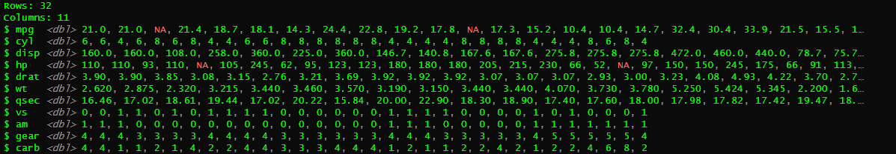

summary(eda_df)
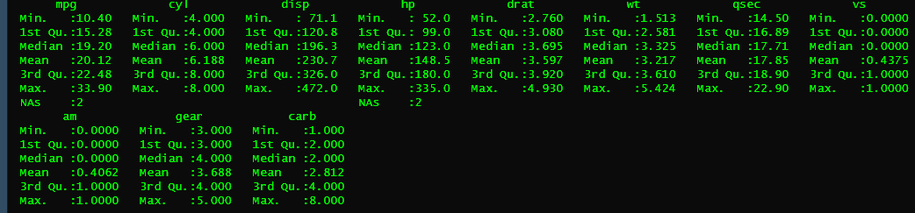

# Missing Values Audit
sum(is.na(eda_df)) # Total missing
[1] 4
colSums(is.na(eda_df)) # Missing per column
mpg cyl disp hp drat wt qsec vs am gear carb
2 0 0 2 0 0 0 0 0 0 0

# Correlation Analysis
numeric_vars <- eda_df |> select(mpg, cyl, disp, hp, wt)
cor_matrix <- cor(numeric_vars, use = "complete.obs")
round(cor_matrix, 2)

mpg cyl disp hp wt
mpg 1.00 -0.87 -0.86 -0.77 -0.86
cyl -0.87 1.00 0.89 0.83 0.76
disp -0.86 0.89 1.00 0.78 0.89
hp -0.77 0.83 0.78 1.00 0.63
wt -0.86 0.76 0.89 0.63 1.00

# Drop Missing Values
clean_eda_df <- eda_df |> drop_na(mpg, hp)

Day 21: Mini-Project 2
What to learn:
- Complete visual exploratory report
- End-to-end from raw data to visualizations

Summary Code:
r
library(tidyverse)

set.seed(42)
report_data <- data.frame(
Country = rep(c("Malaysia", "Indonesia", "Thailand", "Vietnam"), each = 10),
Year = rep(2014:2023, times = 4),
Inflation = rnorm(40, mean = 2.8, sd = 1.1),
GDP_Growth = rnorm(40, mean = 4.5, sd = 1.8),
Sector = rep(c("Manufacturing", "Services"), times = 20)
)

# Plot 1: Time-Series Trajectories
plot_trends <- report_data |>
ggplot(aes(x = Year, y = GDP_Growth, color = Country)) +
geom_line(linewidth = 1) +
geom_point(size = 1.5) +
labs(
title = "Macroeconomic Performance Report",
subtitle = "Figure 1: Annual GDP Growth Trajectories (2014-2023)",
x = "Year", y = "GDP Growth (%)", color = "Country"
) +
theme_bw() +
theme(plot.title = element_text(face = "bold", size = 12))

print(plot_trends)

# Plot 2: Relationship Analysis & Faceting
plot_relationships <- report_data |>
ggplot(aes(x = Inflation, y = GDP_Growth, color = Country)) +
geom_point(size = 2.5, alpha = 0.8) +
geom_smooth(method = "lm", se = FALSE, linetype = "dashed", color = "black") +
facet_wrap(~ Sector) +
labs(
subtitle = "Figure 2: Growth vs. Inflation Dynamics by Economic Sector",
x = "Inflation Rate (%)", y = "GDP Growth (%)",
caption = "Source: Simulated Macroeconomic Panel Database"
) +
theme_minimal() +
theme(plot.subtitle = element_text(face = "italic", size = 10),
legend.position = "bottom")

print(plot_relationships)

📅 PHASE 4: STATISTICS & MODELING (Days 22-28)
Day 22: Descriptive Statistics
What to learn:
- Mean, median, mode
- Variance, standard deviation
- Quantiles, IQR
Summary Code:
r
library(tidyverse)

# Descriptive Statistics Functions
data <- c(2.1, 2.5, 1.8, 3.0, 2.7, 2.3)

mean(data)
[1] 2.4

median(data)
[1] 2.4

sd(data)
[1] 0.4289522 # Standard deviation

var(data) # Variance
[1] 0.184

min(data)
[1] 1.8

max(data)
[1] 3

quantile(data, probs = c(0.25, 0.75))
25% 75%
2.15 2.65

IQR(data)
[1] 0.5

# Quick Summary
summary(data)
Min. 1st Qu. Median Mean 3rd Qu. Max.
1.80 2.15 2.40 2.40 2.65 3.00

# Using with Data Frames
summary(mtcars) <------------ summarize data

Day 23: Probability & Sampling
What to learn:
- Statistical distributions (Normal, Binomial)
- Random sampling in R

Summary Code:
r
# Normal Distribution
rnorm(10, mean = 0, sd = 1) # Generate random normal
[1] -0.56327807 -0.41223878 -0.55300183 -1.74716687 1.16883264
[6] 0.53387782 -0.82184931 -1.25939618 -0.07978505 0.39777233

dnorm(0, mean = 0, sd = 1) # Density at x=0
[1] 0.3989423

pnorm(1.96, mean = 0, sd = 1) # Cumulative probability
[1] 0.9750021

qnorm(0.975, mean = 0, sd = 1) # Quantile
[1] 1.959964

# Binomial Distribution
rbinom(10, size = 10, prob = 0.5) # Generate random binomial
[1] 5 7 6 7 6 6 8 4 4 3

dbinom(5, size = 10, prob = 0.5) # Probability of exactly 5 successes
[1] 0.2460938

#Poisson Distribution

library(tidyverse)

# Set seed for reproducible random numbers
set.seed(42)

# POISSON DISTRIBUTION (Discrete Count Data)
# Models the number of events occurring in a fixed interval (e.g., website visits per hour)
# Lambda (lambda) = expected average rate of occurrence (e.g., 4 events per hour)

# Generate 1,000 random counts from a Poisson distribution
poisson_data <- rpois(n = 1000, lambda = 4)

# Quick summary of the generated counts
print("Poisson Data Summary:")
print(summary(poisson_data))
Min. 1st Qu. Median Mean 3rd Qu. Max.
0.00 2.00 4.00 3.92 5.00 11.00

# Visualize the Poisson distribution
tibble(Count = poisson_data) |>
ggplot(aes(x = Count)) +
geom_bar(fill = "steelblue", color = "black", alpha = 0.8) +
labs(
title = "Poisson Distribution (lambda = 4)",
subtitle = "Discrete counts of events over a fixed interval",
x = "Number of Events",
y = "Frequency"
) +
theme_minimal()
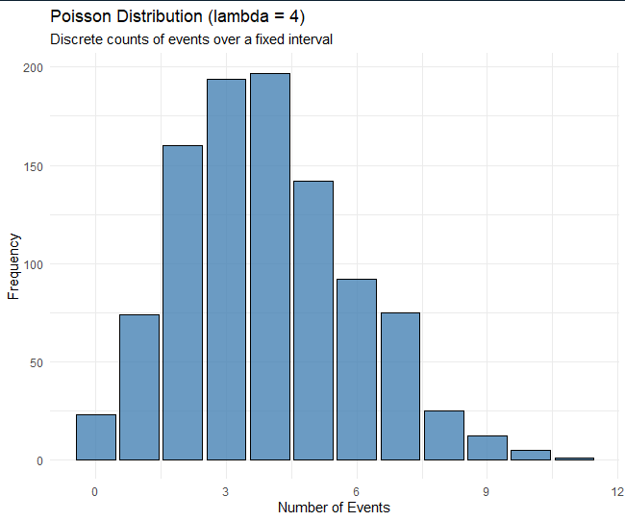

# UNIFORM DISTRIBUTION (Continuous & Equal Probability)
# Models a continuous range where every value between a minimum and maximum
# has an equal chance of occurring (e.g., waiting times between 0 and 10 minutes)

# Generate 1,000 random values uniformly distributed between min = 0 and max = 10
uniform_data <- runif(n = 1000, min = 0, max = 10)

print("Uniform Data Summary:")
print(summary(uniform_data))
Min. 1st Qu. Median Mean 3rd Qu. Max.
0.003735 2.385863 5.024530 4.970157 7.563358 9.997632

# Visualize the Uniform distribution (forms a flat horizontal rectangle)
tibble(Value = uniform_data) |>
ggplot(aes(x = Value)) +
geom_histogram(bins = 30, fill = "darkorange", color = "white", alpha = 0.8) +
labs(
title = "Continuous Uniform Distribution (Min = 0, Max = 10)",
subtitle = "Equal probability density across the entire range",
x = "Value",
y = "Count"
) +
theme_minimal()
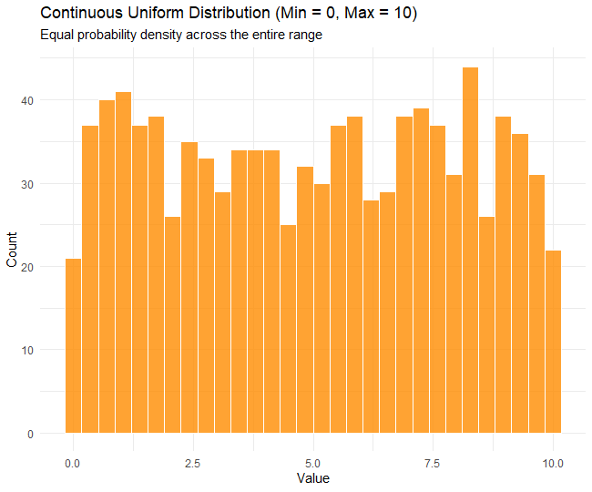

# NON-UNIFORM DISTRIBUTION (Custom Probabilities)

# Models a categorical or discrete variable where different outcomes
# have unequal (custom) probabilities of being selected (e.g., market states:
# Growth with 60% chance, Stagnation with 30%, Recession with 10%)

categories <- c("Growth", "Stagnation", "Recession")
custom_probabilities <- c(0.60, 0.30, 0.10)

# Sample 1,000 times from these categories using the specified weights
non_uniform_data <- sample(categories, size = 1000, replace = TRUE, prob = custom_probabilities)

# Calculate proportions to verify they match our weights
print("Non-Uniform Sample Proportions:")
print(prop.table(table(non_uniform_data)))
non_uniform_data
Growth Recession Stagnation
0.586 0.101 0.313

# Visualize the Non-Uniform distribution
tibble(State = non_uniform_data) |>
ggplot(aes(x = State, fill = State)) +
geom_bar(alpha = 0.8) +
labs(
title = "Non-Uniform (Custom Probability) Distribution",
subtitle = "Categories with unequal selection weights",
x = "Economic State",
y = "Count"
) +
theme_minimal() +
theme(legend.position = "none")
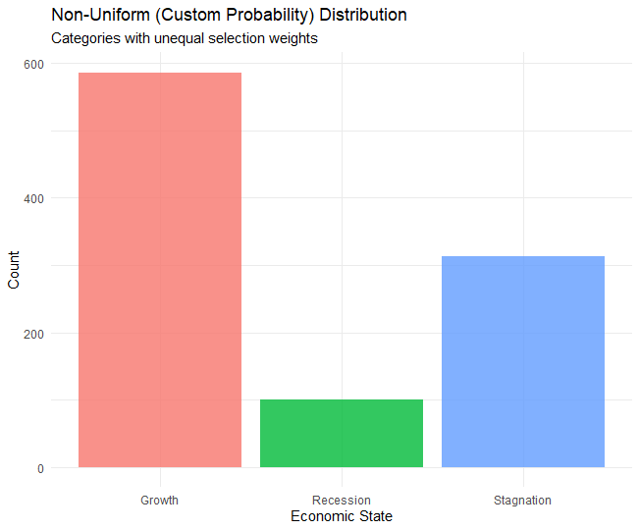

# 4. EXPONENTIAL DISTRIBUTION (Time Between Events)
# Models the time between independent Poisson events
# (e.g., time until the next customer arrives, or machine failure time)
# Rate (rate) = lambda parameter (e.g., an average rate of 0.5 events per minute)

# Generate 1,000 random values from an exponential distribution
exponential_data <- rexp(n = 1000, rate = 0.5)

print("Exponential Data Summary:")
print(summary(exponential_data))
Min. 1st Qu. Median Mean 3rd Qu. Max.
0.000524 0.533849 1.263931 1.926045 2.653703 16.383286

# Visualize the Exponential distribution (skewed right, long tail)
tibble(Time = exponential_data) |>
ggplot(aes(x = Time)) +
geom_histogram(bins = 40, fill = "forestgreen", color = "white", alpha = 0.8) +
labs(
title = "Exponential Distribution (Rate = 0.5)",
subtitle = "Models time or distance between independent events",
x = "Time Elapsed",
y = "Count"
) +
theme_minimal()

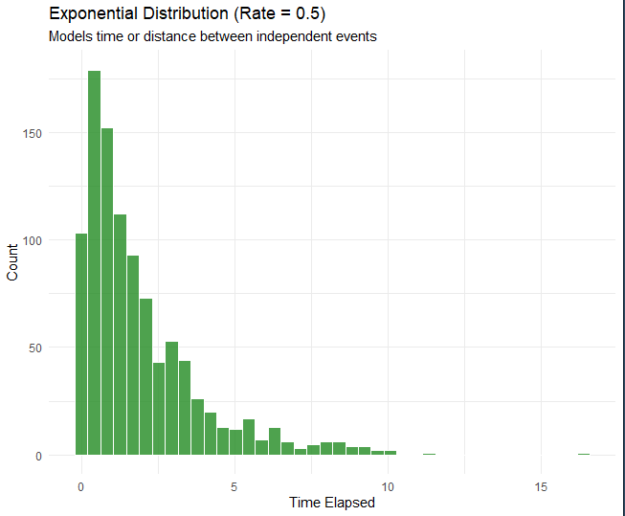

# Random Sampling
sample(1:100, 10) # Random sample of 10 from 1 to 100
[1] 8 60 94 75 46 50 20 45 96 78

set.seed(123) # For reproducibility
sample(c("A", "B", "C"), 10, replace = TRUE, prob = c(0.3, 0.5, 0.2))
[1] "B" "A" "B" "C" "C" "B" "A" "C" "A" "B"

Day 24: Hypothesis Testing
What to learn:
- One-sample T-test
- Two-sample T-test
- Chi-Square test
Summary Code:
r
# One-Sample T-Test
data <- c(3.5, 3.8, 4.0, 3.9, 4.1, 3.7, 3.6, 4.2)
t.test(data, mu = 4.0) # Test if mean = 4.0

One Sample t-test

data: data
t = -1.7321, df = 7, p-value = 0.1269
alternative hypothesis: true mean is not equal to 4
95 percent confidence interval:
3.645218 4.054782
sample estimates:
mean of x
3.85

# Two-Sample T-Test
group1 <- c(2.5, 2.8, 3.0, 2.7, 2.9)
group2 <- c(3.2, 3.5, 3.3, 3.8, 3.1)
t.test(group1, group2, var.equal = TRUE)

Two Sample t-test

data: group1 and group2
t = -3.9736, df = 8, p-value = 0.004098
alternative hypothesis: true difference in means is not equal to 0
95 percent confidence interval:
-0.948199 -0.251801
sample estimates:
mean of x mean of y
2.78 3.38

# Chi-Square Test
observed <- matrix(c(30, 10, 15, 25), nrow = 2, ncol = 2)
chisq.test(observed)

Pearson's Chi-squared test with Yates' continuity correction

data: observed
X-squared = 9.9556, df = 1, p-value = 0.001604

Day 25: Simple Linear Regression
What to learn:
- Fitting models using lm()
- Interpreting coefficients
- R², p-values

Summary Code:
r
# Simple Linear Regression
model <- lm(mpg ~ wt, data = mtcars)
summary(model)

Call:
lm(formula = mpg ~ wt, data = mtcars)

Residuals:
Min 1Q Median 3Q Max
-4.5432 -2.3647 -0.1252 1.4096 6.8727

Coefficients:
Estimate Std. Error t value Pr(>|t|)
(Intercept) 37.2851 1.8776 19.858 < 2e-16 ***
wt -5.3445 0.5591 -9.559 1.29e-10 ***
---
Signif. codes: 0 ‘***’ 0.001 ‘**’ 0.01 ‘*’ 0.05 ‘.’ 0.1 ‘ ’ 1

Residual standard error: 3.046 on 30 degrees of freedom
Multiple R-squared: 0.7528, Adjusted R-squared: 0.7446
F-statistic: 91.38 on 1 and 30 DF, p-value: 1.294e-10

# Extract Coefficients
coef(model)
(Intercept) wt
37.285126 -5.344472

# Confidence Intervals
confint(model, level = 0.95)
2.5 % 97.5 %
(Intercept) 33.450500 41.119753
wt -6.486308 -4.202635

# Fitted Values and Residuals
model_results <- mtcars |>
mutate(
Fitted_MPG = fitted(model),
Residuals = residuals(model)
)

# Model Diagnostics
# plot(model)

Day 26: Multiple Regression & Evaluation
What to learn:
- Multiple predictors
- Checking assumptions
- Model evaluation

Summary Code:
r
# Multiple Linear Regression
model <- lm(mpg ~ wt + hp + cyl, data = mtcars)
summary(model)

Call:
lm(formula = mpg ~ wt + hp + cyl, data = mtcars)

Residuals:
Min 1Q Median 3Q Max
-3.9290 -1.5598 -0.5311 1.1850 5.8986

Coefficients:
Estimate Std. Error t value Pr(>|t|)
(Intercept) 38.75179 1.78686 21.687 < 2e-16 ***
wt -3.16697 0.74058 -4.276 0.000199 ***
hp -0.01804 0.01188 -1.519 0.140015
cyl -0.94162 0.55092 -1.709 0.098480 .
---
Signif. codes: 0 ‘***’ 0.001 ‘**’ 0.01 ‘*’ 0.05 ‘.’ 0.1 ‘ ’ 1

Residual standard error: 2.512 on 28 degrees of freedom
Multiple R-squared: 0.8431, Adjusted R-squared: 0.8263
F-statistic: 50.17 on 3 and 28 DF, p-value: 2.184e-11

# Add Interaction Term
model_interaction <- lm(mpg ~ wt * hp, data = mtcars)
summary(model_interaction)
Call:
lm(formula = mpg ~ wt * hp, data = mtcars)

Residuals:
Min 1Q Median 3Q Max
-3.0632 -1.6491 -0.7362 1.4211 4.5513

Coefficients:
Estimate Std. Error t value Pr(>|t|)
(Intercept) 49.80842 3.60516 13.816 5.01e-14 ***
wt -8.21662 1.26971 -6.471 5.20e-07 ***
hp -0.12010 0.02470 -4.863 4.04e-05 ***
wt:hp 0.02785 0.00742 3.753 0.000811 ***
---
Signif. codes: 0 ‘***’ 0.001 ‘**’ 0.01 ‘*’ 0.05 ‘.’ 0.1 ‘ ’ 1

Residual standard error: 2.153 on 28 degrees of freedom
Multiple R-squared: 0.8848, Adjusted R-squared: 0.8724
F-statistic: 71.66 on 3 and 28 DF, p-value: 2.981e-13

# Model Comparison
anova(model, model_interaction)
Analysis of Variance Table

Model 1: mpg ~ wt + hp + cyl
Model 2: mpg ~ wt * hp
Res.Df RSS Df Sum of Sq F Pr(>F)
1 28 176.62
2 28 129.76 0 46.859

# Diagnostic Plots
par(mfrow = c(2, 2))
plot(model)
par(mfrow = c(1, 1))
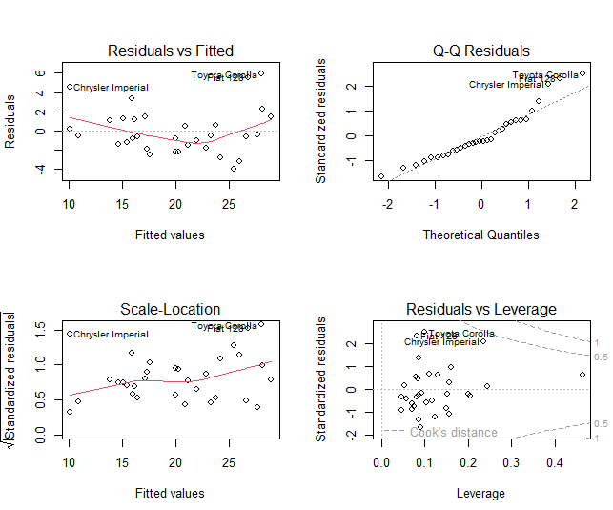
# Check Multicollinearity (VIF)
# install.packages("car")
library(car)
vif(model)
wt hp cyl
2.580486 3.258481 4.757456

Day 27: One-Way ANOVA
(Comparing means of one categorical variable with >2 levels)
r
# Load data
data(mtcars)

# Convert cylinder to a factor (categorical)
mtcars$cyl <- as.factor(mtcars$cyl)

# One-Way ANOVA: Is MPG significantly different across cylinder groups?
anova_one <- aov(mpg ~ cyl, data = mtcars)
summary(anova_one) # Check the p-value (Pr(>F))

Df Sum Sq Mean Sq F value Pr(>F)
cyl 2 824.8 412.4 39.7 4.98e-09 ***
Residuals 29 301.3 10.4
---
Signif. codes: 0 ‘***’ 0.001 ‘**’ 0.01 ‘*’ 0.05 ‘.’ 0.1 ‘ ’ 1

# Post-hoc test: Which specific groups are different?
tukey_result <- TukeyHSD(anova_one)
print(tukey_result)

Tukey multiple comparisons of means
95% family-wise confidence level

Fit: aov(formula = mpg ~ cyl, data = mtcars)

$cyl
diff lwr upr p adj
6-4 -6.920779 -10.769350 -3.0722086 0.0003424
8-4 -11.563636 -14.770779 -8.3564942 0.0000000
8-6 -4.642857 -8.327583 -0.9581313 0.0112287

# Visualize the differences
plot(tukey_result, las = 1)
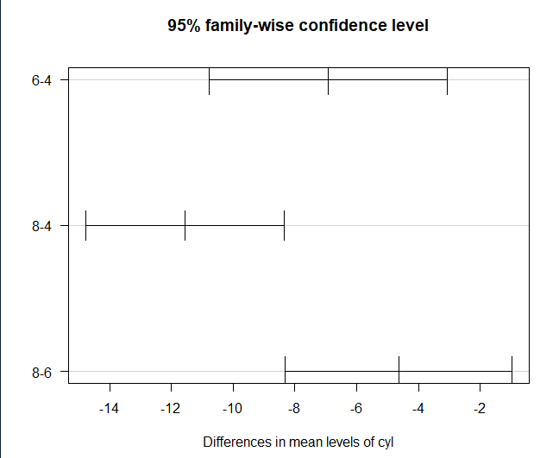

# Assumption check: Homogeneity of variances (Levene's test)
# install.packages("car")
library(car)
leveneTest(mpg ~ cyl, data = mtcars)

Levene's Test for Homogeneity of Variance (center = median)
Df F value Pr(>F)
group 2 5.5071 0.00939 **
29
---
Signif. codes: 0 ‘***’ 0.001 ‘**’ 0.01 ‘*’ 0.05 ‘.’ 0.1 ‘ ’ 1

28: Two-Way ANOVA
(Comparing means across two categorical variables and their interaction)
r
# Add transmission (am) as a second factor
mtcars$am <- as.factor(mtcars$am) # 0 = automatic, 1 = manual

# Two-Way ANOVA with interaction (cyl * am)
anova_two <- aov(mpg ~ cyl * am, data = mtcars)
summary(anova_two) # Check significance of cyl, am, and cyl:am interaction

Df Sum Sq Mean Sq F value Pr(>F)
cyl 1 817.7 817.7 94.642 1.76e-10 ***
am 1 37.0 37.0 4.279 0.0479 *
cyl:am 1 29.4 29.4 3.407 0.0755 .
Residuals 28 241.9 8.6
---
Signif. codes: 0 ‘***’ 0.001 ‘**’ 0.01 ‘*’ 0.05 ‘.’ 0.1 ‘ ’ 1

# Alternative syntax (explicit main effects + interaction)
anova_two_alt <- aov(mpg ~ cyl + am + cyl:am, data = mtcars)
summary(anova_two_alt)
Df Sum Sq Mean Sq F value Pr(>F)
cyl 1 817.7 817.7 94.642 1.76e-10 ***
am 1 37.0 37.0 4.279 0.0479 *
cyl:am 1 29.4 29.4 3.407 0.0755 .
Residuals 28 241.9 8.6
---
Signif. codes: 0 ‘***’ 0.001 ‘**’ 0.01 ‘*’ 0.05 ‘.’ 0.1 ‘ ’ 1

# Visualize interaction (Does the effect of cylinders depend on transmission?)
interaction.plot(x.factor = mtcars$cyl,
trace.factor = mtcars$am,
response = mtcars$mpg,
fun = mean,
type = "b",
col = c("blue", "red"),
xlab = "Cylinders",
ylab = "Mean MPG",
trace.label = "Transmission")
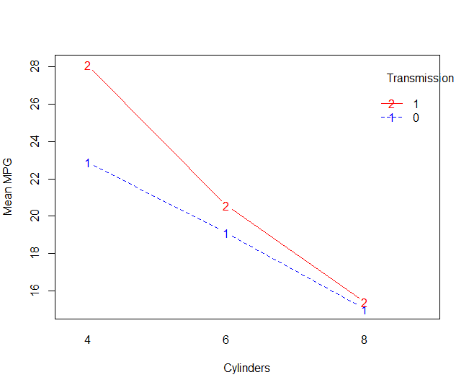

📅 PHASE 5: APPLIED ECONOMETRICS (Days 29-35+)
Day 29: OLS & Diagnostics
What to learn:
- Multiple linear regression
- Testing assumptions
- Multicollinearity, heteroskedasticity
Summary Code:
r
# Multiple Linear Regression
model <- lm(mpg ~ wt + hp + disp + cyl, data = mtcars)
summary(model)
Call:
lm(formula = mpg ~ wt + hp + disp + cyl, data = mtcars)

Residuals:
Min 1Q Median 3Q Max
-4.0562 -1.4636 -0.4281 1.2854 5.8269

Coefficients:
Estimate Std. Error t value Pr(>|t|)
(Intercept) 40.82854 2.75747 14.807 1.76e-14 ***
wt -3.85390 1.01547 -3.795 0.000759 ***
hp -0.02054 0.01215 -1.691 0.102379
disp 0.01160 0.01173 0.989 0.331386
cyl -1.29332 0.65588 -1.972 0.058947 .
---
Signif. codes: 0 ‘***’ 0.001 ‘**’ 0.01 ‘*’ 0.05 ‘.’ 0.1 ‘ ’ 1

Residual standard error: 2.513 on 27 degrees of freedom
Multiple R-squared: 0.8486, Adjusted R-squared: 0.8262
F-statistic: 37.84 on 4 and 27 DF, p-value: 1.061e-10

# Heteroskedasticity Tests
# install.packages("lmtest")
library(lmtest)
bptest(model) # Breusch-Pagan test

studentized Breusch-Pagan test

data: model
BP = 2.7623, df = 4, p-value = 0.5984

# install.packages("car")
library(car)
ncvTest(model) # Non-constant variance test
Non-constant Variance Score Test
Variance formula: ~ fitted.values
Chisquare = 2.758708, Df = 1, p = 0.096726

# Multicollinearity
vif(model)
wt hp disp cyl
4.848016 3.405983 10.373286 6.737707

# Robust Standard Errors
# install.packages("sandwich")
library(sandwich)
coeftest(model, vcov = vcovHC(model, type = "HC1"))
t test of coefficients:

Estimate Std. Error t value Pr(>|t|)
(Intercept) 40.8285367 2.5819001 15.8134 3.560e-15 ***
wt -3.8539035 0.8390770 -4.5930 9.091e-05 ***
hp -0.0205384 0.0096109 -2.1370 0.04181 *
disp 0.0115992 0.0076466 1.5169 0.14091
cyl -1.2933197 0.5664892 -2.2830 0.03052 *
---
Signif. codes: 0 ‘***’ 0.001 ‘**’ 0.01 ‘*’ 0.05 ‘.’ 0.1 ‘ ’ 1

Day 30: Panel Data Structure (plm)
What to learn:
- Declaring panel data objects
- Pooled OLS vs First-Differences

Summary Code:
r
# install.packages("plm")
library(plm)

# Create Panel Data
panel_df <- data.frame(
Country = rep(c("Malaysia", "Indonesia", "Thailand"), each = 5),
Year = rep(2019:2023, times = 3),
GDP_Growth = rnorm(15, mean = 4, sd = 1.5),
Investment = rnorm(15, mean = 25, sd = 5),
Inflation = rnorm(15, mean = 3, sd = 1)
)
# Declare Panel Data
pdata <- pdata.frame(panel_df, index = c("Country", "Year"))

# Pooled OLS
pooled_model <- plm(GDP_Growth ~ Investment + Inflation,
data = pdata, model = "pooling")
summary(pooled_model)
Pooling Model
Call:
plm(formula = GDP_Growth ~ Investment + Inflation, data = pdata,
model = "pooling")

Balanced Panel: n = 3, T = 5, N = 15

Residuals:
Min. 1st Qu. Median 3rd Qu. Max.
-1.2769 -0.7039 0.0643 0.6581 1.6698

Coefficients:
Estimate Std. Error t-value Pr(>|t|)
(Intercept) 7.043940 1.666580 4.2266 0.001175 **
Investment -0.089786 0.053439 -1.6801 0.118752
Inflation -0.161648 0.238999 -0.6764 0.511642
---
Signif. codes: 0 ‘***’ 0.001 ‘**’ 0.01 ‘*’ 0.05 ‘.’ 0.1 ‘ ’ 1

Total Sum of Squares: 13.961
Residual Sum of Squares: 11.211
R-Squared: 0.19699
Adj. R-Squared: 0.063159
F-statistic: 1.47192 on 2 and 12 DF, p-value: 0.26811

# First-Differences
fd_model <- plm(GDP_Growth ~ Investment + Inflation,
data = pdata, model = "fd")
summary(fd_model)

Oneway (individual) effect First-Difference Model

Call:
plm(formula = GDP_Growth ~ Investment + Inflation, data = pdata,
model = "fd")

Balanced Panel: n = 3, T = 5, N = 15
Observations used in estimation: 12

Residuals:
Min. 1st Qu. Median 3rd Qu. Max.
-2.645 -0.324 0.229 0.650 1.497

Coefficients:
Estimate Std. Error t-value Pr(>|t|)
(Intercept) -0.171788 0.368197 -0.4666 0.65190
Investment -0.085647 0.045887 -1.8665 0.09483 .
Inflation -0.161369 0.331786 -0.4864 0.63833
---
Signif. codes: 0 ‘***’ 0.001 ‘**’ 0.01 ‘*’ 0.05 ‘.’ 0.1 ‘ ’ 1

Total Sum of Squares: 19.408
Residual Sum of Squares: 13.688
R-Squared: 0.29468
Adj. R-Squared: 0.13795
F-statistic: 1.88012 on 2 and 9 DF, p-value: 0.20784

Day 31: Fixed & Random Effects
What to learn:
- Within (Fixed Effects)
- Random Effects
- Hausman Test

Summary Code:
# ==========================================
# 1. LOAD LIBRARIES AND SETUP DATA
# ==========================================
library(tidyverse)
library(plm) # Essential for panel data econometrics

# Simulate a balanced panel dataset (e.g., 5 countries observed over 6 years)
set.seed(2026)
n_countries <- 5
n_years <- 6

panel_df <- data.frame(
Country = rep(c("Malaysia", "Indonesia", "Thailand", "Vietnam", "Philippines"), each = n_years),
Year = rep(2018:2023, times = n_countries),
Investment = runif(n_countries * n_years, min = 15, max = 45),
Trade_Openness = runif(n_countries * n_years, min = 60, max = 140)
)

# Create unobserved country-specific effects and generate dependent variable (GDP Growth)
country_effect <- rep(c(1.2, 2.0, 0.8, 2.5, 1.5), each = n_years)
panel_df$GDP_Growth <- 0.07 * panel_df$Investment + 0.03 * panel_df$Trade_Openness + country_effect + rnorm(30, mean = 0, sd = 0.5)

# Convert the standard data frame into a panel data object (pdata.frame)
# index = c("Entity/Group", "Time")
pdata <- pdata.frame(panel_df, index = c("Country", "Year"))

# ==========================================
# 2. ESTIMATING THE FIXED EFFECTS (FE) MODEL
# ==========================================
# model = "within" isolates within-entity variation and removes unobserved time-invariant bias
fe_model <- plm(GDP_Growth ~ Investment + Trade_Openness,
data = pdata,
model = "within")

print("--- Fixed Effects Model Summary ---")
summary(fe_model)
Oneway (individual) effect Within Model

Call:
plm(formula = GDP_Growth ~ Investment + Trade_Openness, data = pdata,
model = "within")

Balanced Panel: n = 5, T = 6, N = 30

Residuals:
Min. 1st Qu. Median 3rd Qu. Max.
-0.60949 -0.31004 0.00794 0.33313 0.70267

Coefficients:
Estimate Std. Error t-value Pr(>|t|)
Investment 0.0675949 0.0106880 6.3244 1.876e-06 ***
Trade_Openness 0.0297472 0.0032922 9.0356 4.997e-09 ***
---
Signif. codes: 0 ‘***’ 0.001 ‘**’ 0.01 ‘*’ 0.05 ‘.’ 0.1 ‘ ’ 1

Total Sum of Squares: 27.407
Residual Sum of Squares: 3.7775
R-Squared: 0.86217
Adj. R-Squared: 0.82621
F-statistic: 71.935 on 2 and 23 DF, p-value: 1.2663e-10

# Extract individual country-specific intercepts/fixed effects
print("Estimated Country Fixed Effects:")
print(fixef(fe_model))
Indonesia Malaysia Philippines Thailand Vietnam
2.01908 1.37657 1.25487 0.88409 2.52859

# ==========================================
# 3. ESTIMATING THE RANDOM EFFECTS (RE) MODEL
# ==========================================
# model = "random" treats unobserved effects as random error components
re_model <- plm(GDP_Growth ~ Investment + Trade_Openness,
data = pdata,
model = "random")

print("--- Random Effects Model Summary ---")
summary(re_model)
Call:
plm(formula = GDP_Growth ~ Investment + Trade_Openness, data = pdata,
model = "random")

Balanced Panel: n = 5, T = 6, N = 30

Effects:
var std.dev share
idiosyncratic 0.16424 0.40527 0.809
individual 0.03872 0.19677 0.191
theta: 0.3564

Residuals:
Min. 1st Qu. Median 3rd Qu. Max.
-1.0843 -0.2770 -0.0326 0.3427 1.0661

Coefficients:
Estimate Std. Error z-value Pr(>|z|)
(Intercept) 1.3563975 0.5405492 2.5093 0.0121 *
Investment 0.0633578 0.0137394 4.6114 4.000e-06 ***
Trade_Openness 0.0333270 0.0042264 7.8854 3.136e-15 ***
---
Signif. codes: 0 ‘***’ 0.001 ‘**’ 0.01 ‘*’ 0.05 ‘.’ 0.1 ‘ ’ 1

Total Sum of Squares: 35
Residual Sum of Squares: 7.8282
R-Squared: 0.77634
Adj. R-Squared: 0.75977
Chisq: 93.718 on 2 DF, p-value: < 2.22e-16

# ==========================================
# 4. HAUSMAN SPECIFICATION TEST (FE vs. RE)
# ==========================================
# Tests whether individual effects are correlated with the regressors.
# H0: Random Effects is consistent and preferred (no correlation).
# H1: Random Effects is biased; must use Fixed Effects (correlation exists).

hausman_result <- phtest(fe_model, re_model)

print("--- Hausman Test Results ---")
print(hausman_result)

Hausman Test

data: GDP_Growth ~ Investment + Trade_Openness
chisq = 1.9915, df = 2, p-value = 0.3694
alternative hypothesis: one model is inconsistent

# Decision Rule Note:
# If p-value < 0.05, reject H0 -> Use Fixed Effects.
# If p-value > 0.05, fail to reject H0 -> Use Random Effects.

Day 32: Advanced Panel & High-Dimensional FE
What to learn:
- fixest package for fast multi-way fixed effects
- Controlling for entity and year simultaneously

Summary Code:
r
# install.packages("fixest")
library(fixest)

# Create dataset with entity and time FEs
panel_df <- data.frame(
Country = rep(c("Malaysia", "Indonesia", "Thailand"), each = 10),
Year = rep(2014:2023, times = 3),
GDP_Growth = rnorm(30, mean = 4, sd = 1.5),
Investment = rnorm(30, mean = 25, sd = 5),
Inflation = rnorm(30, mean = 3, sd = 1)
)

# Fixed Effects with fixest (country and year fixed effects)
feols_model <- feols(GDP_Growth ~ Investment + Inflation | Country + Year,
data = panel_df)
summary(feols_model)

OLS estimation, Dep. Var.: GDP_Growth
Observations: 30
Fixed-effects: Country: 3, Year: 10
Standard-errors: IID
Estimate Std. Error t value Pr(>|t|)
Investment 0.039600 0.067518 0.586513 0.56571
Inflation -0.394676 0.425281 -0.928037 0.36718
---
Signif. codes: 0 '***' 0.001 '**' 0.01 '*' 0.05 '.' 0.1 ' ' 1
RMSE: 1.27181 Adj. R2: -0.137096
Within R2: 0.058948

# Multi-way clustering
feols_model_clustered <- feols(GDP_Growth ~ Investment + Inflation | Country + Year,
data = panel_df, cluster = ~Country + Year)
summary(feols_model_clustered)
OLS estimation, Dep. Var.: GDP_Growth
Observations: 30
Fixed-effects: Country: 3, Year: 10
Standard-errors: Clustered (Country & Year)
Estimate Std. Error t value Pr(>|t|)
Investment 0.039600 0.028366 1.396032 0.29748
Inflation -0.394676 0.606397 -0.650854 0.58193
---
Signif. codes: 0 '***' 0.001 '**' 0.01 '*' 0.05 '.' 0.1 ' ' 1
RMSE: 1.27181 Adj. R2: -0.137096
Within R2: 0.058948

# Compare with plm
library(plm)
pdata <- pdata.frame(panel_df, index = c("Country", "Year"))
plm_model <- plm(GDP_Growth ~ Investment + Inflation,
data = pdata, model = "within", effect = "twoways")
summary(plm_model)
Twoways effects Within Model

Call:
plm(formula = GDP_Growth ~ Investment + Inflation, data = pdata,
effect = "twoways", model = "within")

Balanced Panel: n = 3, T = 10, N = 30

Residuals:
Min. 1st Qu. Median 3rd Qu. Max.
-2.357 -0.860 -0.103 1.197 2.360

Coefficients:
Estimate Std. Error t-value Pr(>|t|)
Investment 0.039600 0.067518 0.5865 0.5657
Inflation -0.394676 0.425281 -0.9280 0.3672

Total Sum of Squares: 51.564
Residual Sum of Squares: 48.525
R-Squared: 0.058948
Adj. R-Squared: -0.70566
F-statistic: 0.501126 on 2 and 16 DF, p-value: 0.61505

Day 33: Causal Inference Basics
What to learn:
- Instrumental Variables (2SLS)
- Difference-in-Differences (DiD)

Summary Code:
# ==========================================
# 1. LOAD LIBRARIES AND SETUP DATA
# ==========================================
library(tidyverse)

# Simulate a quasi-experimental dataset
# Scenario: Evaluating the impact of a minimum wage hike on local employment rates.
# Treatment Group: States that implemented the hike.
# Control Group: Neighboring states that did not.
set.seed(42)
n_obs <- 400

did_df <- data.frame(
id = 1:n_obs,
treated = rep(c(0, 1), each = n_obs / 2), # 0 = Control Group, 1 = Treatment Group
post = rep(c(0, 1), times = n_obs / 2) # 0 = Pre-Treatment Period, 1 = Post-Treatment Period
)

# Simulate the outcome (Employment Rate) with a TRUE causal effect of +4.2
# True Formula: Y = Baseline + GroupEffect + TimeTrend + (CausalEffect * Treated * Post) + Error
did_df$employment_rate <- 55.0 +
3.0 * did_df$treated +
1.5 * did_df$post +
4.2 * (did_df$treated * did_df$post) + # This interaction term is our Causal Estimator!
rnorm(n_obs, mean = 0, sd = 2.0)

# ==========================================
# 2. ESTIMATING CAUSAL EFFECT VIA OLS (DiD REGRESSION)
# ==========================================
# By using an interaction term (treated * post), OLS automatically calculates
# the Difference-in-Differences estimator.
causal_model <- lm(employment_rate ~ treated * post, data = did_df)

print("--- Causal Model Regression Summary ---")
summary(causal_model)
Call:
lm(formula = employment_rate ~ treated * post, data = did_df)

Residuals:
Min 1Q Median 3Q Max
-5.8682 -1.2771 -0.0559 1.2857 5.3958

Coefficients:
Estimate Std. Error t value Pr(>|t|)
(Intercept) 54.8821 0.1926 284.928 < 2e-16 ***
treated 3.1510 0.2724 11.567 < 2e-16 ***
post 1.6259 0.2724 5.969 5.31e-09 ***
treated:post 4.0531 0.3852 10.521 < 2e-16 ***
---
Signif. codes: 0 ‘***’ 0.001 ‘**’ 0.01 ‘*’ 0.05 ‘.’ 0.1 ‘ ’ 1

Residual standard error: 1.926 on 396 degrees of freedom
Multiple R-squared: 0.7508, Adjusted R-squared: 0.7489
F-statistic: 397.6 on 3 and 396 DF, p-value: < 2.2e-16

# Interpretation of coefficients:
# - treated: Baseline difference between groups before the policy.
# - post: General time trend affecting everyone.
# - treated:post -> THIS IS THE CAUSAL EFFECT of the policy.

# ==========================================
# 3. MANUAL CALCULATION OF DiD (TO SEE THE INTUITION)
# ==========================================
# Let's calculate the group-time means manually to see how DiD works under the hood
did_summary <- did_df |>
group_by(treated, post) |>
summarise(mean_y = mean(employment_rate), .groups = "drop")

print("--- Group-Time Means Table ---")
print(did_summary)
treated post mean_y
<dbl> <dbl> <dbl>
1 0 0 54.9
2 0 1 56.5
3 1 0 58.0
4 1 1 63.

# Manual calculation steps:
# 1. Change over time for Treatment Group
treat_change <- did_summary$mean_y[did_summary$treated == 1 & did_summary$post == 1] -
did_summary$mean_y[did_summary$treated == 1 & did_summary$post == 0]

# 2. Change over time for Control Group (Macro trend)
control_change <- did_summary$mean_y[did_summary$treated == 0 & did_summary$post == 1] -
did_summary$mean_y[did_summary$treated == 0 & did_summary$post == 0]

# 3. Difference-in-Differences (Removes macro trend to isolate causality)
manual_did_effect <- treat_change - control_change
cat("\nManually Calculated DiD Causal Effect:", manual_did_effect, "\n")

# ==========================================
# 4. VISUALIZING PARALLEL TRENDS & CAUSAL IMPACT
# ==========================================
plot_data <- did_df |>
group_by(treated, post) |>
summarise(mean_employment = mean(employment_rate), .groups = "drop") |>
mutate(
Group = if_else(treated == 1, "Treatment Group", "Control Group"),
Period = if_else(post == 1, "Post-Treatment", "Pre-Treatment")
)

ggplot(plot_data, aes(x = Period, y = mean_employment, color = Group, group = Group)) +
geom_line(linewidth = 1.2) +
geom_point(size = 3) +
labs(
title = "Difference-in-Differences Causal Inference",
subtitle = "Visualizing Parallel Trends and Policy Impact",
x = "Time Period",
y = "Average Employment Rate",
color = "Cohort"
) +
theme_minimal()

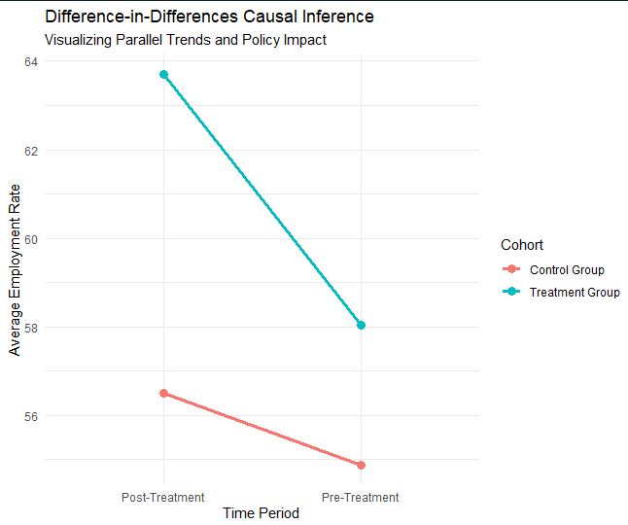

Day 34: Non-linear Models
What to learn:
- Logistic regression
- Probit models
- Poisson models

Summary Code:
r
# Logistic Regression
# Create binary outcome
mtcars$high_mpg <- ifelse(mtcars$mpg > 20, 1, 0)

logit_model <- glm(high_mpg ~ wt + hp, data = mtcars, family = binomial)
summary(logit_model)

Call:
glm(formula = high_mpg ~ wt + hp, family = binomial, data = mtcars)

Coefficients:
Estimate Std. Error z value Pr(>|z|)
(Intercept) 894.228 365884.162 0.002 0.998
wt -202.865 84688.218 -0.002 0.998
hp -2.021 858.062 -0.002 0.998

(Dispersion parameter for binomial family taken to be 1)

Null deviance: 4.3860e+01 on 31 degrees of freedom
Residual deviance: 1.1156e-08 on 29 degrees of freedom
AIC: 6

Number of Fisher Scoring iterations: 25

# Predicted probabilities
mtcars$pred_prob <- predict(logit_model, type = "response")

# Probit Model
probit_model <- glm(high_mpg ~ wt + hp, data = mtcars, family = binomial(link = "probit"))
summary(probit_model)
Call:
glm(formula = high_mpg ~ wt + hp, family = binomial(link = "probit"),
data = mtcars)

Coefficients:
Estimate Std. Error z value Pr(>|z|)
(Intercept) 262.5104 58549.5044 0.004 0.996
wt -59.6114 13537.6593 -0.004 0.996
hp -0.5914 137.9606 -0.004 0.997

(Dispersion parameter for binomial family taken to be 1)

Null deviance: 4.3860e+01 on 31 degrees of freedom
Residual deviance: 1.2574e-08 on 29 degrees of freedom
AIC: 6

Number of Fisher Scoring iterations: 25

# Poisson Regression (for count data)
# install.packages("pscl")
library(pscl)
poisson_model <- glm(cyl ~ wt + hp, data = mtcars, family = poisson)
summary(poisson_model)
Call:
glm(formula = cyl ~ wt + hp, family = poisson, data = mtcars)

Coefficients:
Estimate Std. Error z value Pr(>|z|)
(Intercept) 1.064836 0.257317 4.138 3.5e-05 ***
wt 0.124722 0.090127 1.384 0.166
hp 0.002220 0.001264 1.756 0.079 .
---
Signif. codes: 0 ‘***’ 0.001 ‘**’ 0.01 ‘*’ 0.05 ‘.’ 0.1 ‘ ’ 1

(Dispersion parameter for poisson family taken to be 1)

Null deviance: 16.5743 on 31 degrees of freedom
Residual deviance: 4.1923 on 29 degrees of freedom
AIC: 126.85

Number of Fisher Scoring iterations: 4

Day 35: Time Series
What to learn:
- Time series objects
- ARIMA models
- Forecasting

Summary Code:
r
# install.packages("forecast")
library(forecast)

# Create time series object
ts_data <- ts(mtcars$mpg, frequency = 12, start = c(2020, 1))

# Basic time series plot
autoplot(ts_data)

# ARIMA Model
arima_model <- auto.arima(ts_data)
summary(arima_model)

Series: ts_data
ARIMA(3,0,0) with non-zero mean

Coefficients:
ar1 ar2 ar3 mean
0.4630 0.1525 -0.5500 20.1095
s.e. 0.1395 0.1621 0.1379 0.8012

sigma^2 = 19.28: log likelihood = -91.3
AIC=192.6 AICc=194.91 BIC=199.93

Training set error measures:
ME RMSE MAE MPE MAPE MASE
Training set 0.03908198 4.106841 3.011332 -4.653119 17.02515 0.336838
ACF1
Training set -0.02832793

# Forecast
forecast_result <- forecast(arima_model, h = 5)
autoplot(forecast_result)
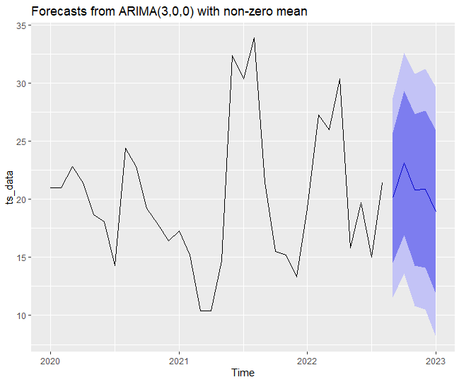

# Alternative: ARIMA with specified order
arima_model2 <- Arima(ts_data, order = c(1, 0, 1))
summary(arima_model2)
Series: ts_data
ARIMA(1,0,1) with non-zero mean

Coefficients:
ar1 ma1 mean
0.3964 0.1250 20.1622
s.e. 0.2233 0.2007 1.6470

sigma^2 = 28.87: log likelihood = -97.78
AIC=203.56 AICc=205.04 BIC=209.42

Training set error measures:
ME RMSE MAE MPE MAPE
Training set -0.01382188 5.115451 3.993568 -6.599673 21.07295
MASE ACF1
Training set 0.4467078 0.04318896

# Ljung-Box Test for residual autocorrelation
Box.test(residuals(arima_model), type = "Ljung-Box")

Box-Ljung test

data: residuals(arima_model)
X-squared = 0.028164, df = 1, p-value = 0.8667

Day 36: VAR (Vector Autoregression)
(Modeling interdependent multiple time-series variables)

r
# Install the missing dependency package
install.packages("strucchange")

# Now load vars successfully
library(vars)
# ==========================================
# 1. LOAD LIBRARIES AND SETUP DATA
# ==========================================
library(tidyverse)
library(vars) # Essential package for Vector Autoregression analysis

# Simulate two related stationary time series (e.g., GDP Growth and Inflation)
set.seed(2026)
n_periods <- 100

# Simulate base GDP growth series
gdp_growth <- rnorm(n_periods, mean = 3.0, sd = 1.5)

# Simulate an inflation series that responds to lagged GDP growth plus some noise
inflation <- numeric(n_periods)
inflation[1] <- 2.0
for(t in 2:n_periods) {
inflation[t] <- 1.5 + 0.4 * gdp_growth[t-1] + rnorm(1, mean = 0, sd = 0.8)
}

# Combine the series into a multivariate time-series matrix (ts object)
macro_matrix <- ts(cbind(GDP_Growth = gdp_growth, Inflation = inflation),
start = c(2001, 1), frequency = 4)

# ==========================================
# 2. SELECTING OPTIMAL LAG LENGTH (VARselect)
# ==========================================
# Before running a VAR, we must determine how many lags (p) to include.
# VARselect evaluates Akaike (AIC), Bayesian (BIC/SC), and Hannan-Quinn criteria.
lag_selection <- VARselect(macro_matrix, lag.max = 4, type = "const")
print("--- Optimal Lag Selection Criteria ---")
print(lag_selection$selection)
AIC(n) HQ(n) SC(n) FPE(n)
3 1 1 3

# ==========================================
# 3. ESTIMATING THE VAR MODEL
# ==========================================
# Estimate the VAR model using 2 lags (or the lag suggested by your VARselect output)
var_model <- VAR(macro_matrix, p = 2, type = "const")

print("--- VAR Model Summary ---")
summary(var_model)
VAR Estimation Results:
=========================
Endogenous variables: GDP_Growth, Inflation
Deterministic variables: const
Sample size: 98
Log Likelihood: -286.009
Roots of the characteristic polynomial:
0.6141 0.486 0.486 0.1001
Call:
VAR(y = macro_matrix, p = 2, type = "const")
Estimation results for equation GDP_Growth:
===========================================
GDP_Growth = GDP_Growth.l1 + Inflation.l1 + GDP_Growth.l2 + Inflation.l2 + const

Estimate Std. Error t value Pr(>|t|)
GDP_Growth.l1 -0.13072 0.10063 -1.299 0.19715
Inflation.l1 -0.01881 0.19575 -0.096 0.92365
GDP_Growth.l2 0.21930 0.12307 1.782 0.07801 .
Inflation.l2 0.25910 0.16317 1.588 0.11570
const 1.93840 0.72777 2.663 0.00911 **
---
Signif. codes: 0 ‘***’ 0.001 ‘**’ 0.01 ‘*’ 0.05 ‘.’ 0.1 ‘ ’ 1
Residual standard error: 1.477 on 93 degrees of freedom
Multiple R-Squared: 0.08287, Adjusted R-squared: 0.04342
F-statistic: 2.101 on 4 and 93 DF, p-value: 0.08691
Estimation results for equation Inflation:
==========================================
Inflation = GDP_Growth.l1 + Inflation.l1 + GDP_Growth.l2 + Inflation.l2 + const

Estimate Std. Error t value Pr(>|t|)
GDP_Growth.l1 0.36130 0.05276 6.848 7.93e-10 ***
Inflation.l1 -0.03015 0.10263 -0.294 0.769614
GDP_Growth.l2 0.04443 0.06452 0.689 0.492772
Inflation.l2 0.11870 0.08555 1.387 0.168609
const 1.32685 0.38155 3.477 0.000772 ***
---
Signif. codes: 0 ‘***’ 0.001 ‘**’ 0.01 ‘*’ 0.05 ‘.’ 0.1 ‘ ’ 1

Residual standard error: 0.7741 on 93 degrees of freedom
Multiple R-Squared: 0.3592, Adjusted R-squared: 0.3317
F-statistic: 13.04 on 4 and 93 DF, p-value: 1.816e-08

Covariance matrix of residuals:
GDP_Growth Inflation
GDP_Growth 2.18010 -0.04268
Inflation -0.04268 0.59925

Correlation matrix of residuals:
GDP_Growth Inflation
GDP_Growth 1.00000 -0.03735
Inflation -0.03735 1.00000

# ==========================================
# 4. GENERATING IMPULSE RESPONSE FUNCTIONS (IRF)
# ==========================================
# IRFs answer the question: "If GDP growth experiences a sudden shock today,
# how will it impact Inflation over the next 8 quarters?"

irf_gdp_to_inf <- irf(
var_model,
impulse = "GDP_Growth", # The variable receiving the shock
response = "Inflation", # The variable reacting to the shock
n.ahead = 8, # How many quarters forward to track
boot = TRUE # Compute bootstrap confidence intervals
)

# Plot the impulse response trajectory
plot(irf_gdp_to_inf,
main = "Impulse Response: Shock to GDP Growth",
ylab = "Response of Inflation",
xlab = "Quarters Ahead")

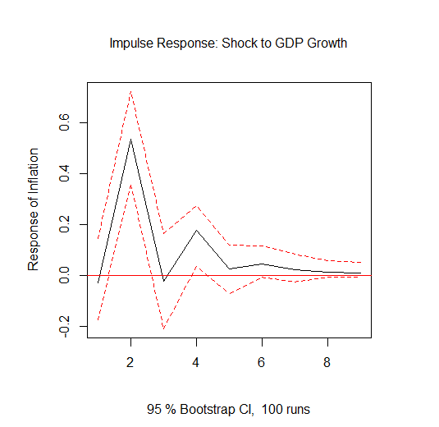
Day 37: ARDL (Autoregressive Distributed Lag)
(Modeling long-run relationships and cointegration with mixed order I(0)/I(1))
r
# Option 1: Using the 'dynlm' package for simple ARDL
# install.packages("dynlm")
library(dynlm)

# Simulate data
set.seed(123)
time <- 1:100
x <- rnorm(100) + cumsum(rnorm(100))*0.1 # I(1) behavior
y <- 2 + 0.5*x + rnorm(100) # Cointegrated relationship

# ARDL(1,1) model: y_t = c + a1*y_{t-1} + b0*x_t + b1*x_{t-1} + e_t
ardl_dynlm <- dynlm(y ~ L(y, 1) + x + L(x, 1))
summary(ardl_dynlm)

Time series regression with "numeric" data:
Start = 1, End = 100

Call:
dynlm(formula = y ~ L(y, 1) + x + L(x, 1))

Residuals:
Min 1Q Median 3Q Max
-2.156e-16 -4.298e-17 -2.390e-17 4.290e-18 2.048e-15

Coefficients: (1 not defined because of singularities)
Estimate Std. Error t value Pr(>|t|)
(Intercept) -7.105e-16 5.467e-17 -1.300e+01 <2e-16 ***
L(y, 1) 1.000e+00 2.323e-17 4.304e+16 <2e-16 ***
x 8.744e-18 2.440e-17 3.580e-01 0.721
L(x, 1) NA NA NA NA
---
Signif. codes: 0 ‘***’ 0.001 ‘**’ 0.01 ‘*’ 0.05 ‘.’ 0.1 ‘ ’ 1

Residual standard error: 2.182e-16 on 97 degrees of freedom
Multiple R-squared: 1, Adjusted R-squared: 1
F-statistic: 1.073e+33 on 2 and 97 DF, p-value: < 2.2e-16

#Option 2
library(ARDL)

# 1. Create a data frame (ensure y and x are defined)
data_ardl <- data.frame(y, x)

# 2. Use auto_ardl() instead of ardl() for automated lag selection
auto_result <- auto_ardl(y ~ x, data = data_ardl, max_order = 4)

# 3. Extract the best model selected by the algorithm
ardl_model <- auto_result$best_model

# 4. View summary and bounds test
summary(ardl_model)
Time series regression with "ts" data:
Start = 4, End = 100

Call:
dynlm::dynlm(formula = full_formula, data = data, start = start,
end = end)

Residuals:
Min 1Q Median 3Q Max
-1.8588 -0.6402 -0.1879 0.6044 2.1225

Coefficients:
Estimate Std. Error t value Pr(>|t|)
(Intercept) 2.12157 0.31300 6.778 1.14e-09 ***
L(y, 1) 0.01877 0.09646 0.195 0.846115
L(y, 2) 0.03161 0.09554 0.331 0.741540
L(y, 3) -0.10717 0.09590 -1.118 0.266652
x 0.40451 0.10297 3.928 0.000165 ***
---
Signif. codes: 0 ‘***’ 0.001 ‘**’ 0.01 ‘*’ 0.05 ‘.’ 0.1 ‘ ’ 1

Residual standard error: 0.9381 on 92 degrees of freedom
Multiple R-squared: 0.1472, Adjusted R-squared: 0.1101
F-statistic: 3.969 on 4 and 92 DF, p-value: 0.005131

bounds_test <- bounds_f_test(ardl_model, case = 3) # Case 3: unrestricted intercept, no trend
print(bounds_test)
Bounds F-test (Wald) for no cointegration

data: d(y) ~ L(y, 1) + x + d(L(y, 1)) + d(L(y, 2))
F = 26.328, p-value = 1e-06
alternative hypothesis: Possible cointegration
null values:
k T
1 1000

# 5. Extract long-run coefficients
long_run <- coef(ardl_model, type = "longrun")
print(long_run)
(Intercept) L(y, 1) L(y, 2) L(y, 3) x
2.12157170 0.01877333 0.03160631 -0.10717422 0.40450990

Day 38: GARCH (Volatility Modeling)
(Modeling time-varying variance / volatility clustering - e.g., financial returns)
r
# install.packages("rugarch")
library(rugarch)

# Use built-in financial returns (S&P 500)
data(sp500ret) # Available in rugarch

# Alternatively, simulate a returns series
set.seed(123)
returns <- rnorm(1000, mean = 0.001, sd = 0.02) # Example returns

# Step 1: Specify the GARCH model
# sGARCH = Standard GARCH(1,1), ARMA(1,1) for the mean equation
spec <- ugarchspec(
variance.model = list(model = "sGARCH", garchOrder = c(1, 1)),
mean.model = list(armaOrder = c(1, 1), include.mean = TRUE),
distribution.model = "norm" # Normal distribution
)
print(spec)
*---------------------------------*
* GARCH Model Spec *
*---------------------------------*

Conditional Variance Dynamics
------------------------------------
GARCH Model : sGARCH(1,1)
Variance Targeting : FALSE

Conditional Mean Dynamics
------------------------------------
Mean Model : ARFIMA(1,0,1)
Include Mean : TRUE
GARCH-in-Mean : FALSE

Conditional Distribution
------------------------------------
Distribution : norm
Includes Skew : FALSE
Includes Shape : FALSE
Includes Lambda : FALSE

# Step 2: Fit the model to the data
garch_fit <- ugarchfit(spec = spec, data = sp500ret)
garch_fit
*---------------------------------*
* GARCH Model Fit *
*---------------------------------*

Conditional Variance Dynamics
-----------------------------------
GARCH Model : sGARCH(1,1)
Mean Model : ARFIMA(1,0,1)
Distribution : norm

Optimal Parameters
------------------------------------
Estimate Std. Error t value Pr(>|t|)
mu 0.000523 0.000087 5.9926 0.00000
ar1 0.870077 0.072183 12.0538 0.00000
ma1 -0.897302 0.064617 -13.8865 0.00000
omega 0.000001 0.000001 1.3971 0.16239
alpha1 0.087711 0.013658 6.4221 0.00000
beta1 0.904940 0.013704 66.0350 0.00000

Robust Standard Errors:
Estimate Std. Error t value Pr(>|t|)
mu 0.000523 0.000129 4.038545 0.000054
ar1 0.870077 0.088201 9.864737 0.000000
ma1 -0.897302 0.080362 -11.165757 0.000000
omega 0.000001 0.000014 0.094161 0.924982
alpha1 0.087711 0.185043 0.474004 0.635497
beta1 0.904940 0.190544 4.749240 0.000002

LogLikelihood : 17902.41

Information Criteria
------------------------------------

Akaike -6.4807
Bayes -6.4735
Shibata -6.4807
Hannan-Quinn -6.4782

Weighted Ljung-Box Test on Standardized Residuals
------------------------------------
statistic p-value
Lag[1] 5.553 1.845e-02
Lag[2*(p+q)+(p+q)-1][5] 6.444 1.225e-05
Lag[4*(p+q)+(p+q)-1][9] 7.200 1.100e-01
d.o.f=2
H0 : No serial correlation

Weighted Ljung-Box Test on Standardized Squared Residuals
------------------------------------
statistic p-value
Lag[1] 1.105 0.2933
Lag[2*(p+q)+(p+q)-1][5] 1.499 0.7401
Lag[4*(p+q)+(p+q)-1][9] 1.958 0.9100
d.o.f=2

Weighted ARCH LM Tests
------------------------------------
Statistic Shape Scale P-Value
ARCH Lag[3] 0.01981 0.500 2.000 0.8881
ARCH Lag[5] 0.17496 1.440 1.667 0.9713
ARCH Lag[7] 0.53652 2.315 1.543 0.9750

Nyblom stability test
------------------------------------
Joint Statistic: 174.2382
Individual Statistics:
mu 0.2054
ar1 0.1482
ma1 0.1051
omega 21.3506
alpha1 0.1346
beta1 0.1134

Asymptotic Critical Values (10% 5% 1%)
Joint Statistic: 1.49 1.68 2.12
Individual Statistic: 0.35 0.47 0.75

Sign Bias Test
------------------------------------
t-value prob sig
Sign Bias 0.4294 6.676e-01
Negative Sign Bias 2.9494 3.198e-03 ***
Positive Sign Bias 2.3922 1.678e-02 **
Joint Effect 28.9851 2.256e-06 ***

Adjusted Pearson Goodness-of-Fit Test:
------------------------------------
group statistic p-value(g-1)
1 20 178.6 5.738e-28
2 30 188.3 2.924e-25
3 40 217.8 1.084e-26
4 50 227.7 7.646e-25

Elapsed time : 2.184252

# Show coefficients (omega, alpha, beta, ar, ma, mu)
coef(garch_fit)
mu ar1 ma1 omega alpha1
5.228661e-04 8.700774e-01 -8.973024e-01 1.340513e-06 8.771123e-02
beta1
9.049395e-01

# Step 3: Check residual diagnostics
plot(garch_fit, which = 8) # QQ-plot
plot(garch_fit, which = 9) # ACF of standardized residuals

# Step 4: Forecast volatility
garch_forecast <- ugarchforecast(garch_fit, n.ahead = 10)
garch_forecast

*------------------------------------*
* GARCH Model Forecast *
*------------------------------------*
Model: sGARCH
Horizon: 10
Roll Steps: 0
Out of Sample: 0

0-roll forecast [T0=2009-01-30]:
Series Sigma
T+1 0.0016633 0.02479
T+2 0.0015151 0.02473
T+3 0.0013862 0.02466
T+4 0.0012740 0.02460
T+5 0.0011764 0.02454
T+6 0.0010915 0.02448
T+7 0.0010176 0.02441
T+8 0.0009534 0.02435
T+9 0.0008974 0.02429
T+10 0.0008488 0.02423

# Extract predicted sigma (volatility) for the next 10 days
sigma_forecast <- sigma(garch_forecast)
print(sigma_forecast)
2009-01-30
T+1 0.02479282
T+2 0.02472867
T+3 0.02466482
T+4 0.02460128
T+5 0.02453805
T+6 0.02447511
T+7 0.02441248
T+8 0.02435015
T+9 0.02428812
T+10 0.02422638

# Step 5: Plot fitted vs actual volatility
plot(garch_fit, which = 3) # Conditional SD / Volatility plot
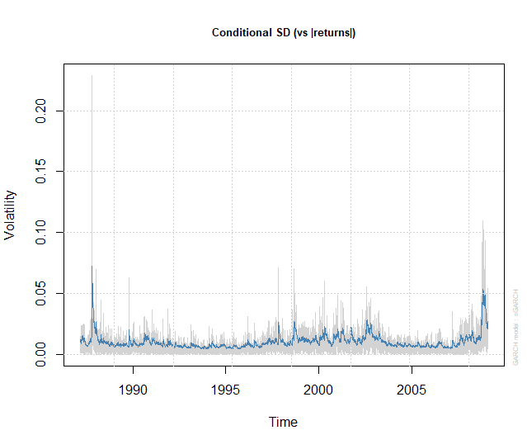
Day | Topic | Status
1 | R Basics & Setup | ☐
2 | Vectors & Matrices | ☐
3 | Lists & Data Frames | ☐
4 | Subsetting & Indexing | ☐
5 | Control Flow | ☐
6 | Custom Functions & Scope | ☐
7 | Basic I/O | ☐
8 | Tidyverse Intro | ☐
9 | dplyr Part 1 | ☐
10 | dplyr Part 2 | ☐
11 | Aggregation | ☐
12 | Combining Datasets | ☐
13 | Reshaping (tidyr) | ☐
14 | Mini-Project 1 (Wrangling) | ☐
15 | ggplot2 Intro | ☐
16 | Basic Plots | ☐
17 | Distribution Plots | ☐
18 | Customizing Visualizations | ☐
19 | Faceting | ☐
20 | Exploratory Data Analysis | ☐
21 | Mini-Project 2 (Visual Report) | ☐
22 | Descriptive Statistics | ☐
23 | Probability & Sampling | ☐
24 | Hypothesis Testing | ☐
25 | Simple Linear Regression | ☐
26 | Multiple Regression | ☐
27 | One-Way ANOVA | ☐
28 | Two-Way ANOVA | ☐
29 | OLS & Diagnostics | ☐
30 | Panel Data (plm) | ☐
31 | Fixed & Random Effects | ☐
32 | High-Dim FE (fixest) | ☐
33 | Causal Inference (IV/DiD) | ☐
34 | Non-linear Models | ☐
35 | Time Series (ARIMA) | ☐
36 | VAR Models | ☐
37 | ARDL Models | ☐
38 | GARCH Models | ☐

